Hi Boys and Girls,

I have been a librarian and teacher for 25 years and the last five of those years; I've spent with the wonderful students of Peekskill schools!

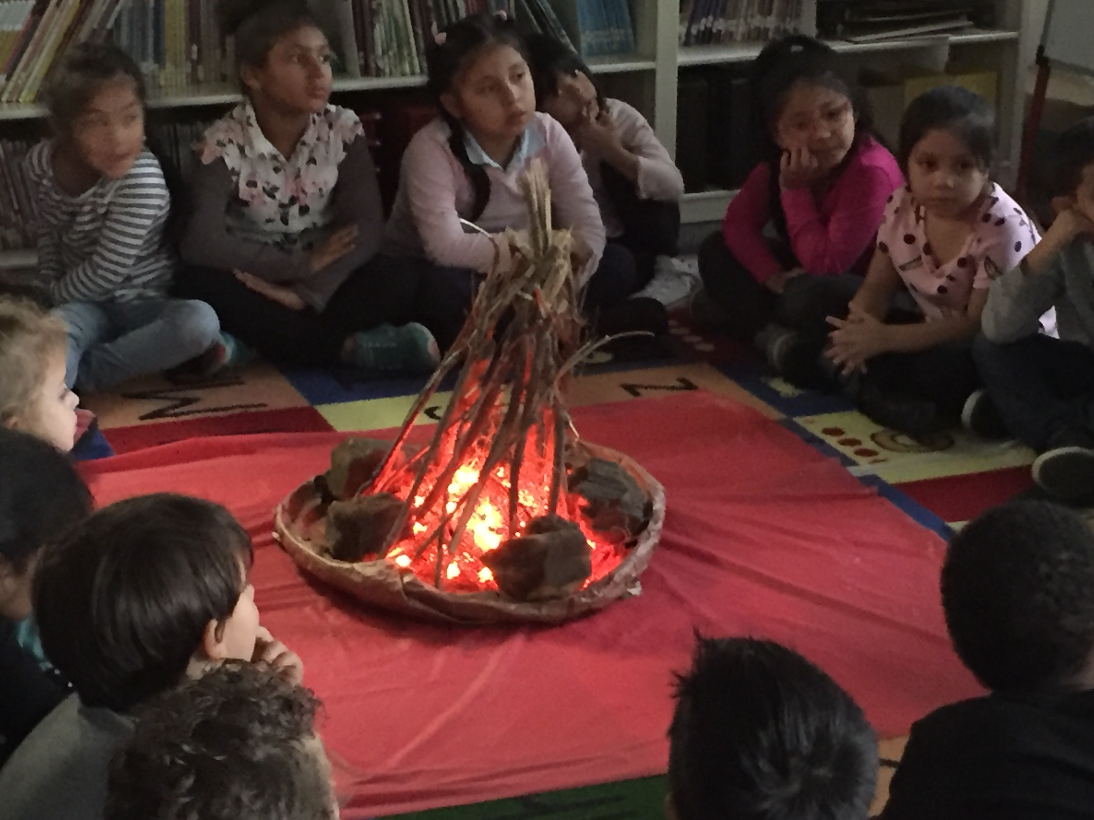

Before teaching in Peekskill, I was a librarian at Renaissance College in Hong Kong.

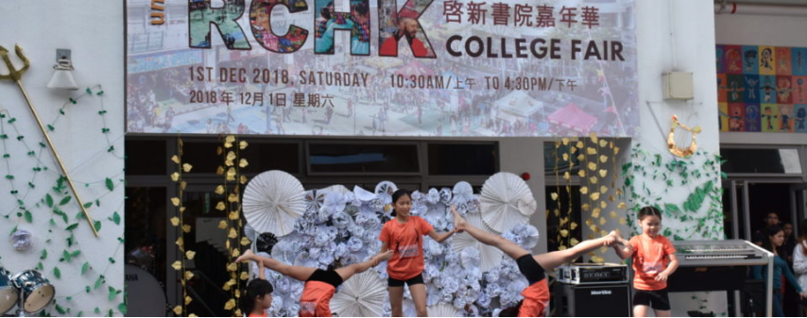

Before H.K., I was the librarian for ICARDA International School of Aleppo, Syria.

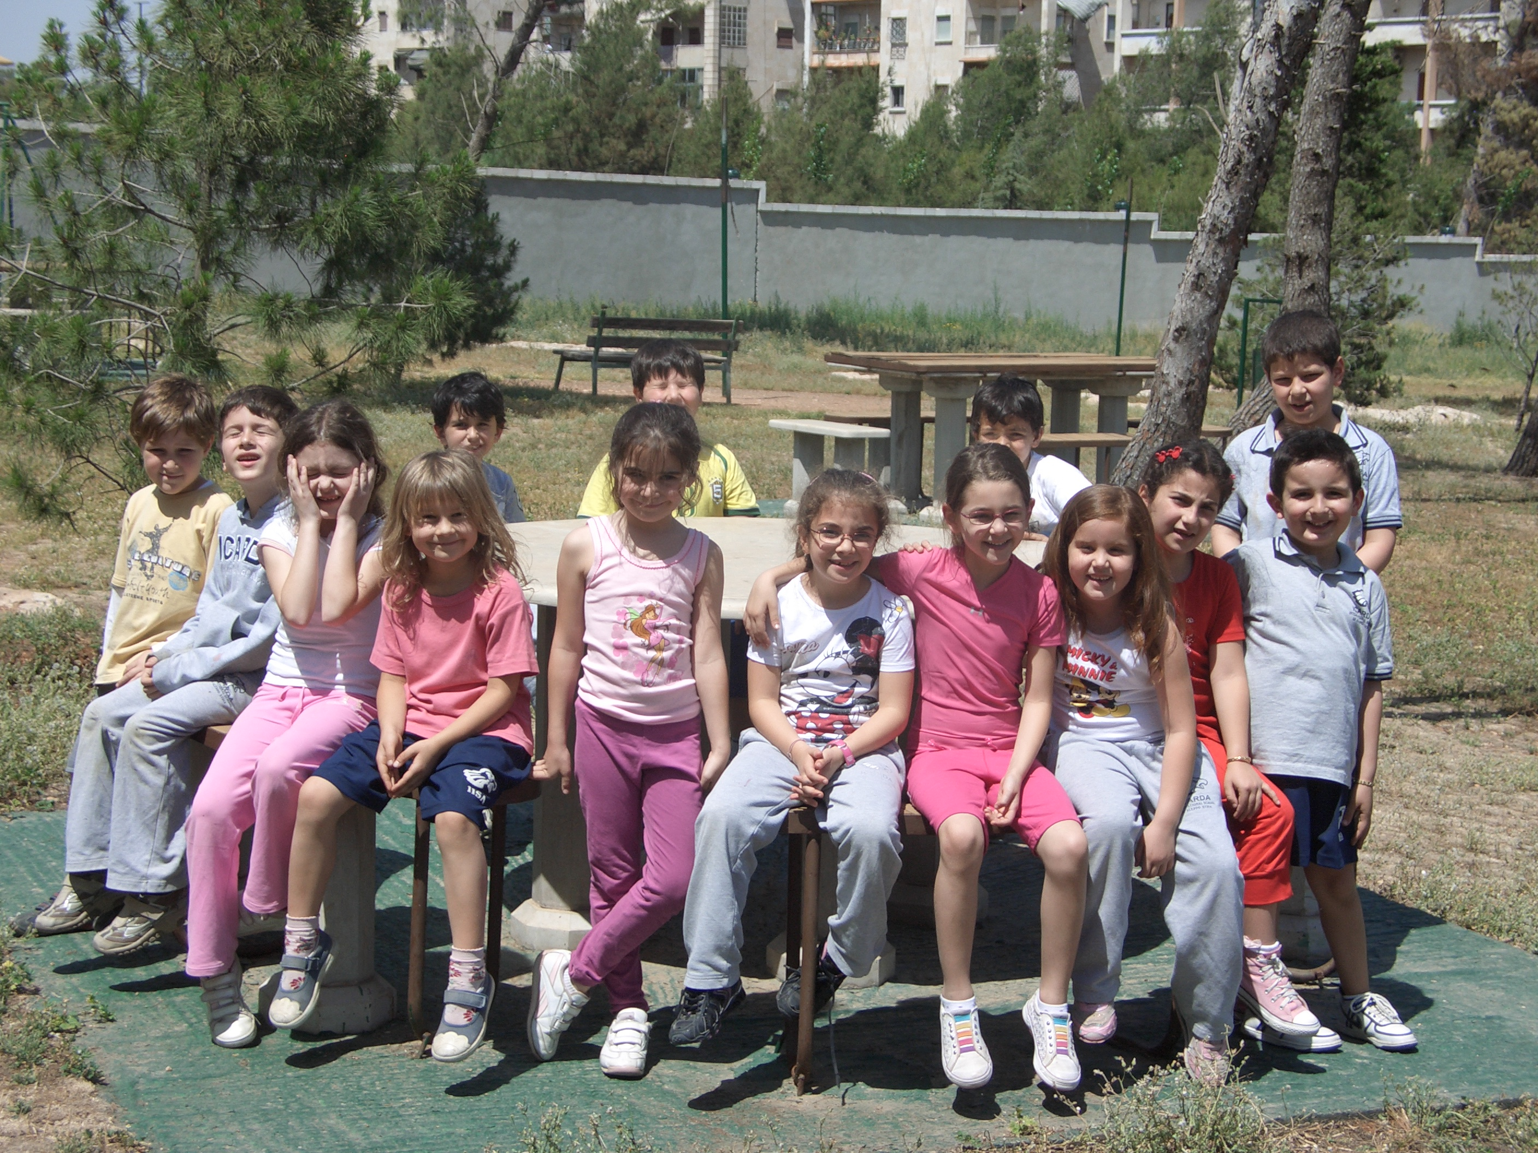 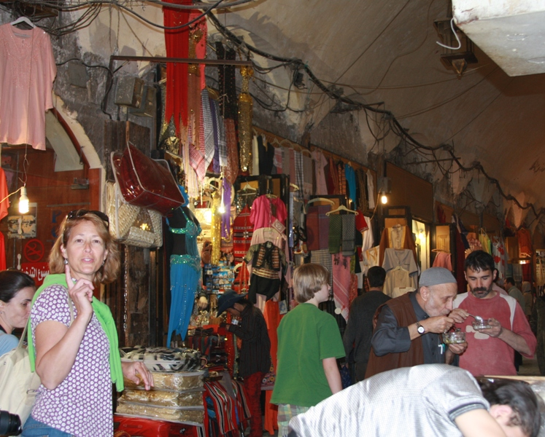

I live in White Plains with my husband and we have 3 grown children who live in different parts of New York. We still love to travel whenever we can because we enjoy meeting people from all over the world.

